Exercise 3
Write a HTML program for the demonstration of Lists.
- Unordered List
- Ordered List
- Definition List
- Nested List

Solution:
- Unordered List:
<html>
<head>
<title> Exercise 3</title>
</head>
<body bgcolor= pink>
<h1 align=center> Course offered by Directorate of Online Education </h1>
<h1 align=center>Manipal University Jaipur</h1>
<ul type=square>
<li>MBA</li>
<li>BBA</li>
<li>MCA</li>
<li>BCA</li>
<li>MCOM</li>
<li>BCOM</li>
<li>MJMC</li>
</ul>
</body>
</html>

Output:-

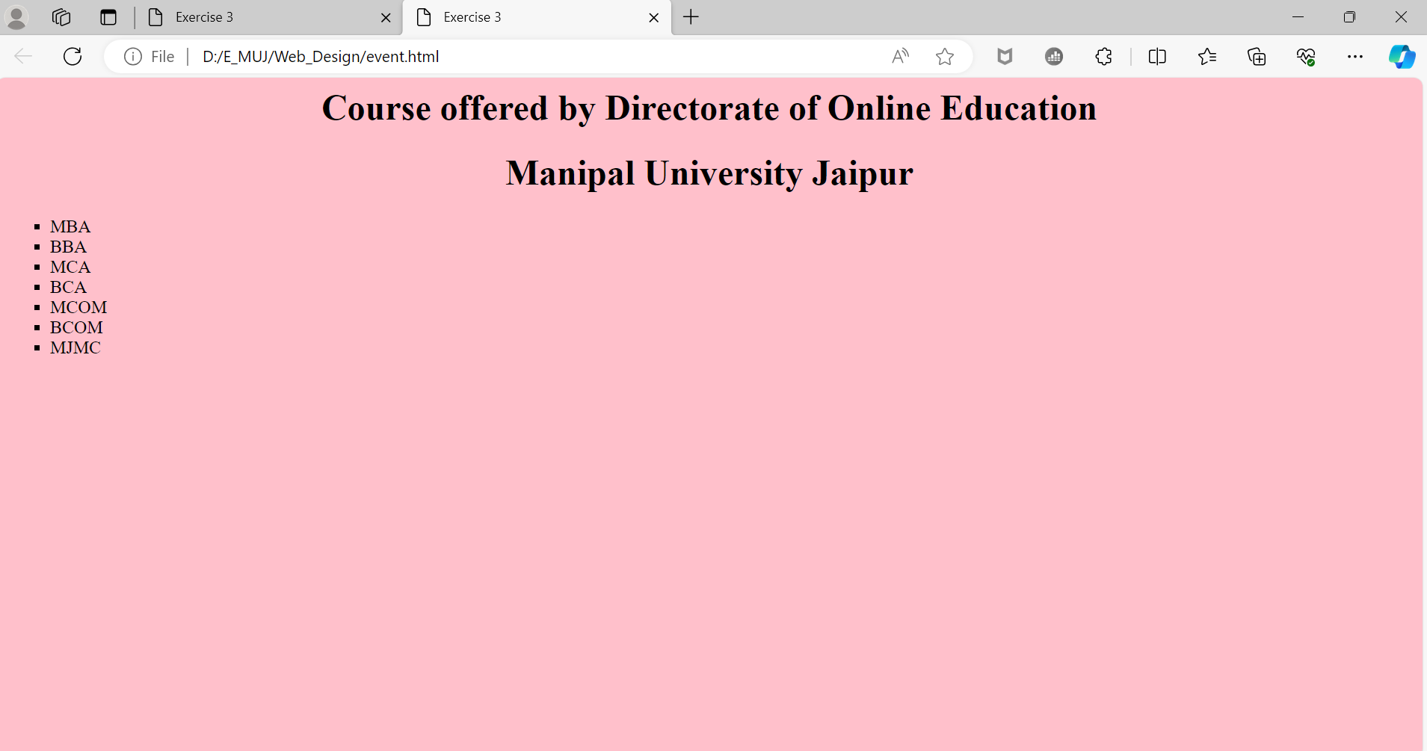

- Ordered List:
Solution:-
<html>
<head>
<title> Exercise 3</title>
</head>
<body bgcolor= pink>
<h1 align=center> Course offered by Directorate of Online Education </h1>
<h1 align=center>Manipal University Jaipur</h1>
<ol type=A>
<li>MBA</li>
<li>BBA</li>
<li>MCA</li>
<li>BCA</li>
<li>MCOM</li>
<li>BCOM</li>
<li>MJMC</li>
</ol>
</body>
</html>
Output:-
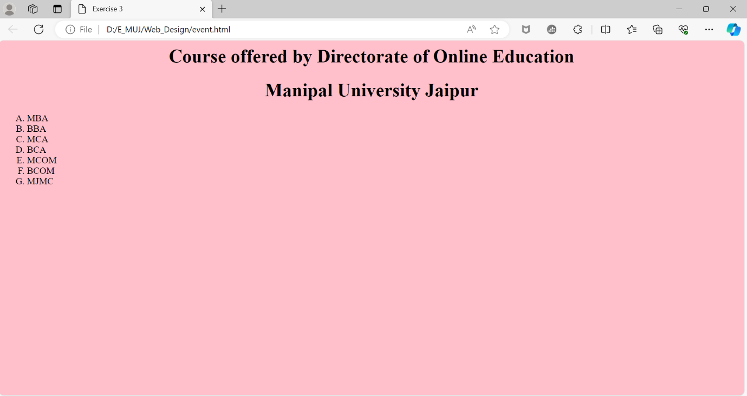

- Definition List:
Solution:-
<html>
<head>
<title> Exercise 3</title>
</head>
<body bgcolor= pink>
<h1 align=center> Course offered by Directorate of Online Education </h1>
<h1 align=center>Manipal University Jaipur</h1>
<h1 align=center>Definition List</h1>
<dl>
<dt>MBA<dd> Master of Business Administration
<dt>BBA<dd> Bachelor of Business Administration
<dt>MCA<dd> Master of Computer Application
<dt>BCA<dd> Bachelor of Computer Application
<dt>MCOM<dd>Master of Commerce
<dt>BCOM<dd> Bachelor of Commerce
<dt>MJMC<dd>Master of Journalism & Mass Communication
</dl>
</body>
</html>

Output:-
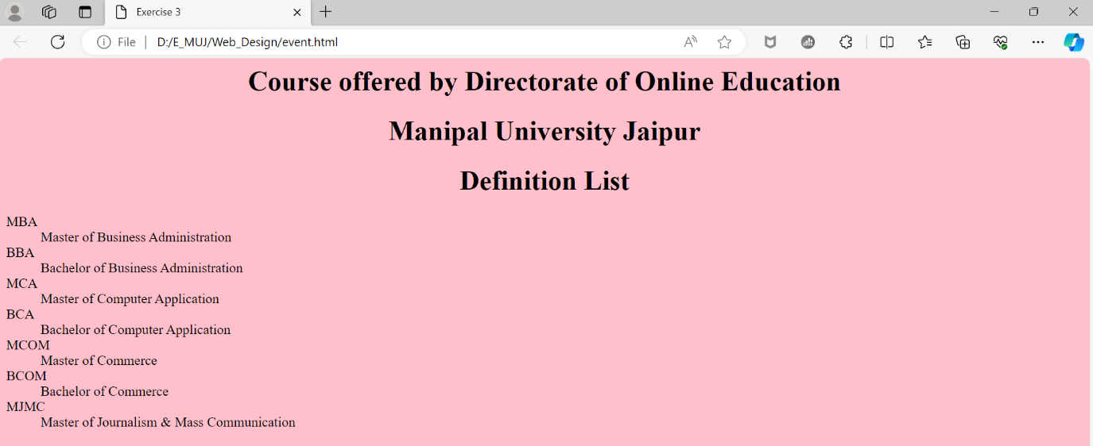

- Nested List:
Solution:-
<html>
<head>
<title> Exercise 3</title>
</head>
<body bgcolor= pink>
<h1 align=center> Course offered by Directorate of Online Education </h1>
<h1 align=center>Manipal University Jaipur</h1>
<h1 align=center>Definition List</h1>
<dl>
<ol>
<li>Computer Application</li>
<ul>
<li>MCA</li>
<li>BCA</li>
</ul>
<li>Bisnuess Adminstration</li>
<ul>
<li>MBA</li>
<li>BBA</li>
</ul>
</ol>
</body>
</html>
Output:-

